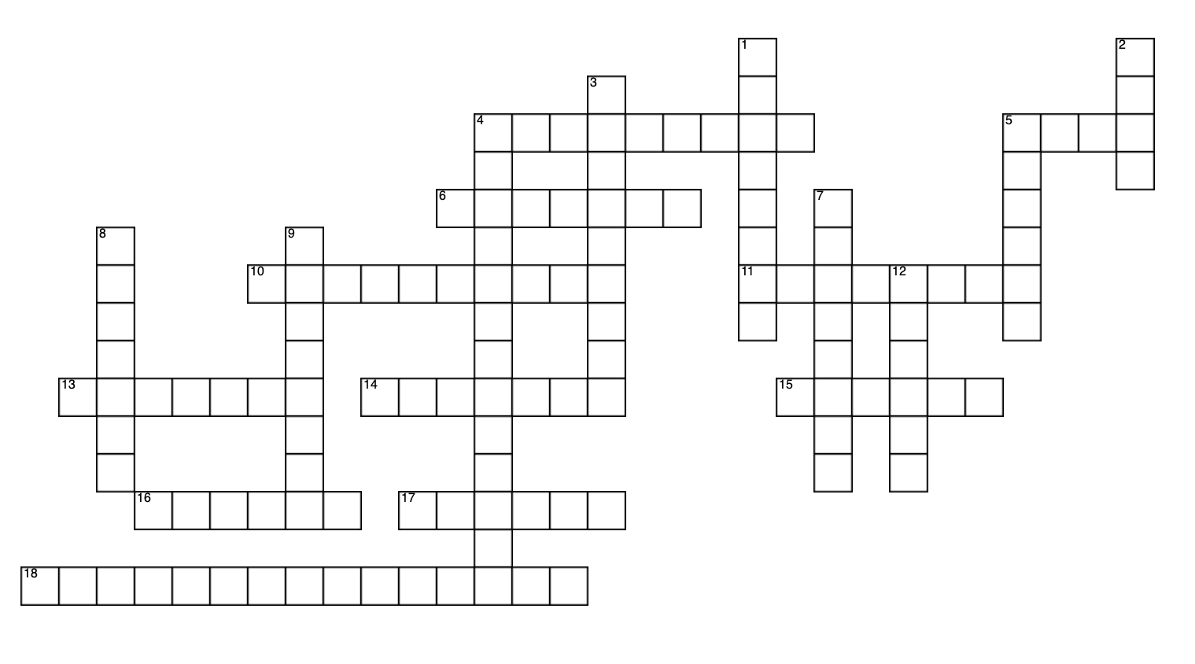
In Your Element
ACROSS
 | 4 | Which radioactive isotope of an essential element is present in all foods and accounts for more than half of the natural radioactivity in our bodies?
 | 5 | Cereals are fortified with which element that also fertilised the abundance of life in the ocean during the last ice age through dust?
 | 6 | Which element was found in high concentrations in Napoleon’s hair, is present in sea creatures such as lobsters and plaice, and is in a frontline treatment for a form of leukaemia?
 | 10 | Which element helps light a match, is in your bones, and limits life in some parts of the ocean?
 | 11 | This element is triple bonded and the main component of our atmosphere and proteins but remarkably difficult for life to access.
 | 13 | This element gives volcanic gas its eggy smell, however it is also a key component of amino acids and proteins for binding metals.
 | 14 | Which element do corals need to produce their skeleton and is also found in milk?
 | 15 | Which metal is common in hand creams and also is most common in mineral water and seawater?
 | 16 | Which unintentionally accumulated gas produced by microorganisms transformed irreversibly the chemical landscape of the Earth 2.5 billion years ago and was essential for the emergence of complex life?
 | 17 | Which element can be found in both Marmite and a blue biro?
 | 18 | Who invented the Periodic Table?
 | DOWN
 | 1 | Which element in acid form can kill you by interfering with calcium in your blood when absorbed through your skin, but is a key ingredient in toothpaste?
 | 2 | Which element in too high a concentration kills bacteria and so is used in mouthwash, but is also key for life as protein fingers?
 | 3 | Which metal burns so brightly it is often found in fireworks, helps balance charge in the body and messed up it is "amusing me"? (anagram)
 | 4 | Edible Apricot cooked for a chemical system. (anagram)
 | 5 | Which element acts as an antiseptic (and can be added to dirty water to make it potable) but is also key for the function of the thyroid?
 | 7 | Which element is against capitalism? (cryptic)
 | 8 | Which element is common to: mad hatters, the smallest planet in the solar system, ointment for treatment of eyelid infections?
 | 9 | This element is used in swimming pools to kill microorganisms which could potentially cause infection. The more the swimming pool smells of it, the more microorganisms have been killed…
 | 12 | This element is highly poisonous to humans on its own, but when combined with different organic compounds, is a highly effective anti-cancer drug.
